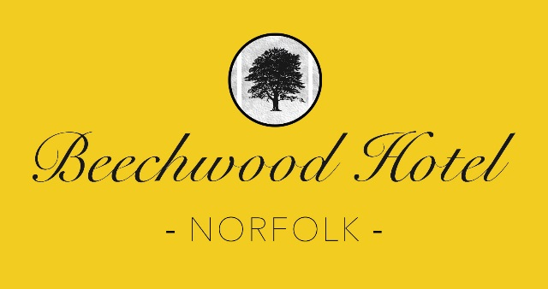

**Finger Buffet Menu 1**

**£29.95 per person**

# Selection of Finger Sandwiches

# Home Made Sausage Rolls

# Cocktail Quiches

# Chicken, Rocket and Lemon Croutons

# Tomato, red onion, basil and Melton cheese mini pizzas

# Scones and Choux Buns

# Coffee and Tea

Some dishes contain nuts and nut derivatives. If any of your

guests have a food allergy please advise us in writing.

Beechwood Hotel, 20 Cromer Road, North Walsham, Norfolk, NR28 0HD

E: [info@beechwood-hotel.co.uk](mailto:info@beechwood-hotel.co.uk) T: 01692 403231